Grading Document

North River Grille Mobile Application

**Project created by: Christopher Lenoci and Paul Hanlon**

This document contains all work done in one-word document for easy grading. All files can be found separately in the zip file.

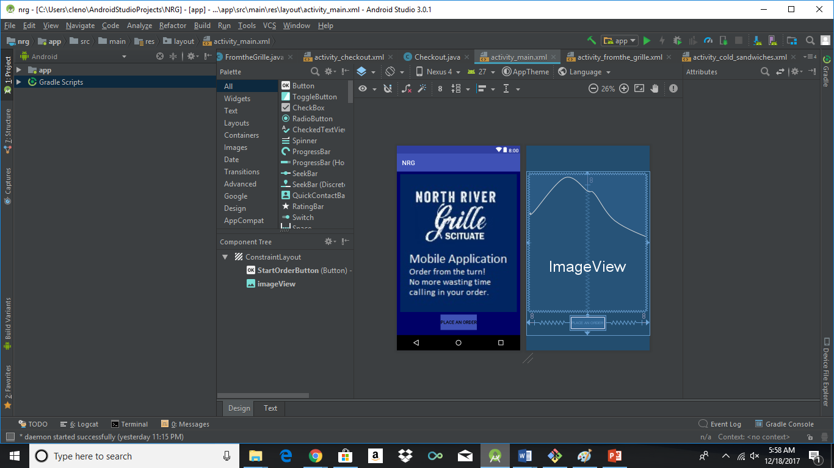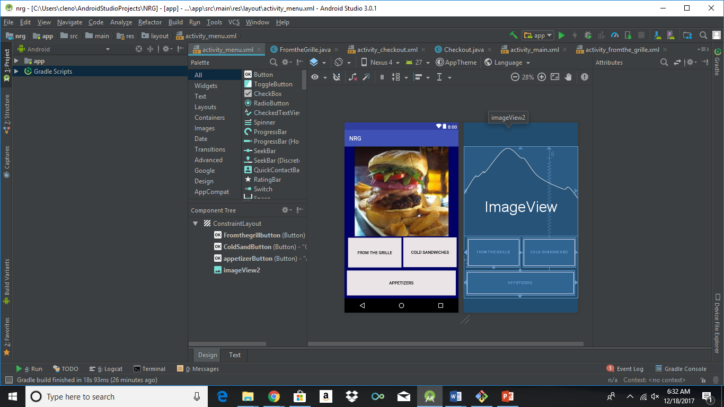

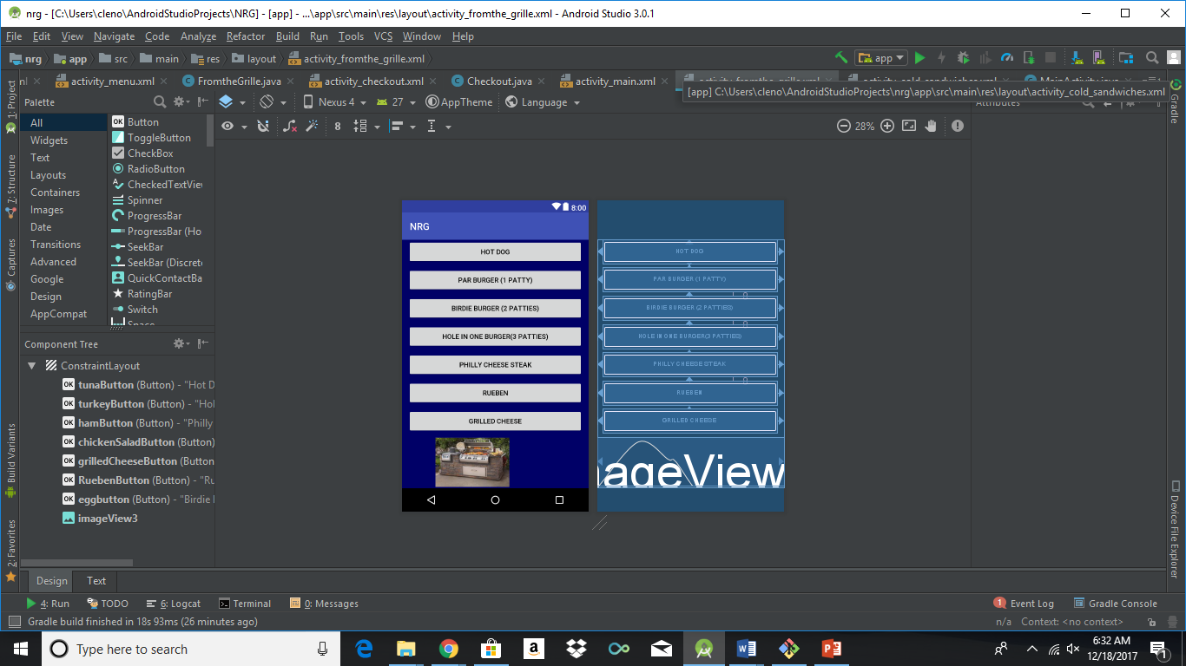

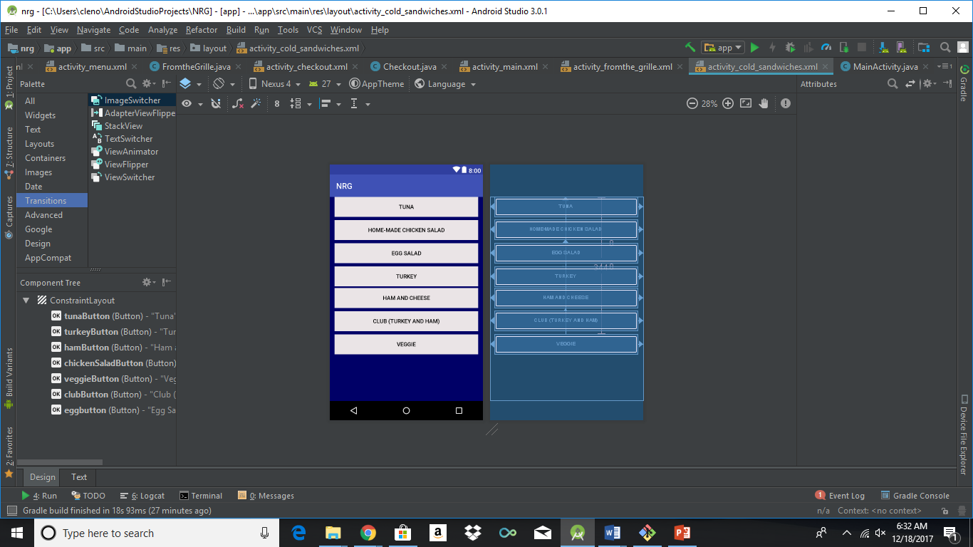

**Project Plan: Schedule**

**2017/11/5** – Met with Mary Quatrucci; Gathered information

**2017/11/15** – Group meeting to plan and divide work

**2017/11/28**– Group meeting; peer review and made revisions

**2017/12/6** – Review all work; Finish presentation; Plan future work

**2017/12/7** – To present a working product to the class

**2017/12/9** – To make functional and aesthetic improvements

**2017/12/12** – To begin improving ease of use and doing some Quality Assurance

**2017/12/15** – To present it to the head chef; Get feedback and make any necessary changes

**2017/12/22** – To submit the final, working product

**Version control : GITHUB**

<https://github.com/Clenoci/NRG-Mobile-Application>

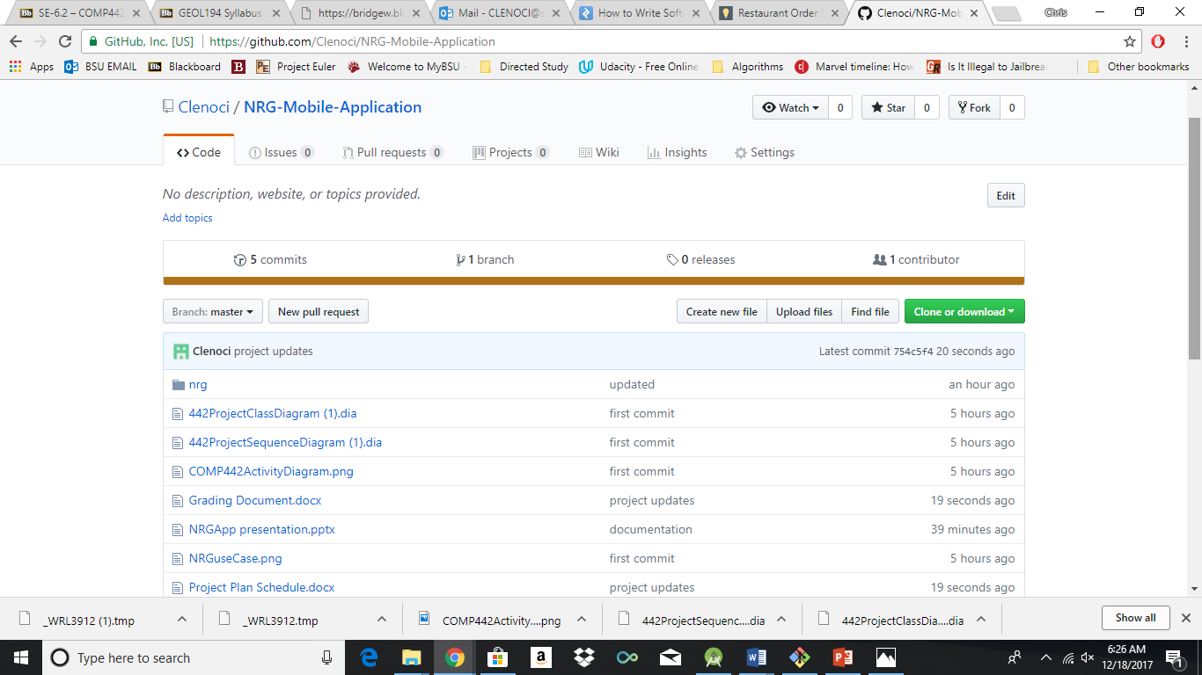

**Requirements**

Mary Quatrucci, the owner of the North River Grille on the Widows Walk golf course in Scituate Ma has come to us about having a mobile application made for her restaurant. She needs a mobile application to allow the golfers to order their food from the course, as the current system for golfers to order from the course is time consuming and cumbersome. Now the golfers must call in their order from the course this takes time away from their golf outing to have to call in their order. It also ties up the employees on the phone inside the restaurant keeping them from attending to the guests that are in the restaurant currently. She would also like the ability to post weekly specials and block out items that she doesn’t currently have in stock. The computer system that is being used was designed to be compatible with smart phone applications, making this project possible.

Functional Requirements:

Application will open-up to a Home screen prompting users to place an order.

Customer will be able to look through the menu

Customer will be able to select what foods they would like, putting them into a cart until checkout

Customer will be able to add delete or modify order until the order is sent to the restaurants

During checkout customer will be able to add their name to an order, for easy identification

Application will give a Digital receipt upon placing an order.

Non-Functional Requirements:

Menu will be broken down into sub-categories to make finding items easier

When an item is added to an order a toast will pop up letting them know their item was added to the cart.

Simple design with functionality at the highest priority

**Design**

Class Diagram

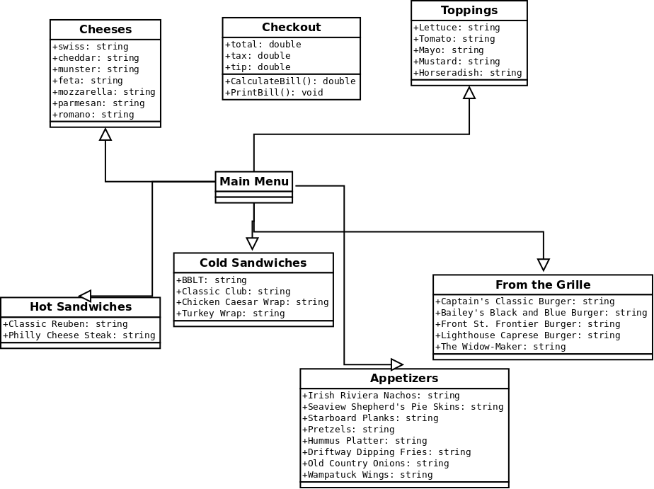

**Sequence Diagram**

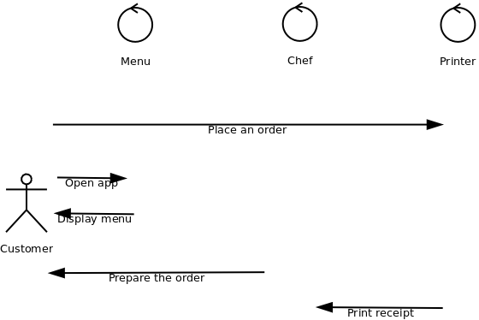

Design:

Using Android studio as the IDE

Written in Java

Simple design, Functionality over everything

Using Blue/White color scheme (colors of restaurant)

Pages for each category of food, One for all toppings

Activity Diagram

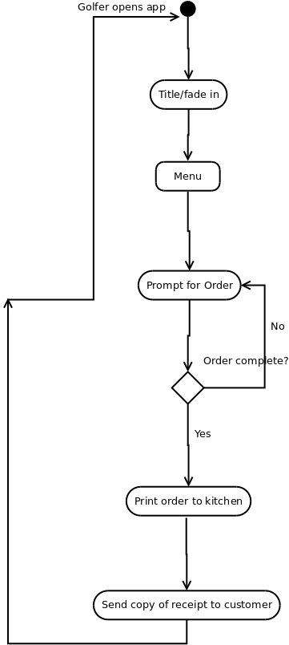

Use Case Diagram

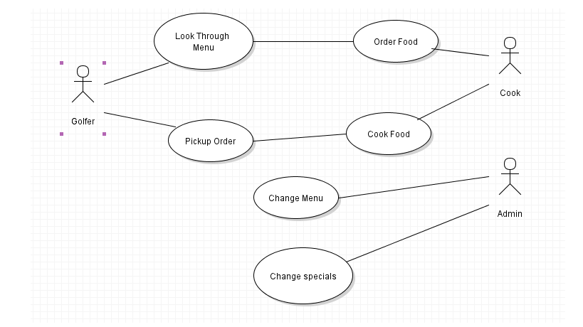

**Test plan**

* Try items in every category.
* Try deleting
* Put through fake orders designed to test every aspect of the app.
* Minimize tests and be efficient
* Test on different types of Android phones(old, new)
* Test on different network than the printer
* Test with no internet connection
* With App still in development test case’s may vary

**Test Cases:**

|  |  |
| --- | --- |
| Test Case Summary | To verify the Order now button works |
| Related Requirement |  |
| Prerequisites | 1. Button is linked to the next page. |
| Test Procedure | 1. Open application 2. Click on Order Now button |
|  |  |
| Expected Result | 1. Upon pressing the button the menu will come up |
| Actual Result | 1. The menu screen pops up |
| Status | Success |
| Remarks |  |
| Created By | Chris Lenoci |
| Date of Creation | 12/1/2017 |
|  |  |
|  |  |

|  |  |
| --- | --- |
| Test Case Summary | Make sure Every Category works |
| Related Requirement | Order now Button works |
| Prerequisites | 1. All buttons are linked to correct pages |
| Test Procedure | 1. Open application 2. Click on Order Now button 3. Click through each page and then back to the original |
|  |  |
| Expected Result | 1. Be able to move through the menu without any interruptions or without getting stuck |
| Actual Result | * 1. Navigated through most pages with ease   2. Some buttons the functionality did not work for |
| Status | Partial-Success |
| Remarks | Some buttons need to be remapped |
| Created By | Chris Lenoci |
| Date of Creation | 12/9/2017 |
|  |  |
|  |  |

|  |  |
| --- | --- |
| Test Case Summary | Check function of Cart |
| Related Requirement | All past test successful |
| Prerequisites | 1. Queue for the cart is set up 2. Delete and Add functions working |
| Test Procedure | 1. Open application 2. Click on Order Now button 3. Click through each page, order one item from each page 4. Try different toppings 5. Then try to delete an item or two |
|  |  |
| Expected Result | 1. Have all items added to Queue 2. Be able to delete select items from cart |
| Actual Result | 1. Most Items go into cart 2. Delete function not working |
| Status | Failure |
| Remarks | Queue needs to be re-worked. |
| Created By | Chris Lenoci |
| Date of Creation | 12/13/2017 |
|  |  |
|  |  |

|  |  |
| --- | --- |
| Test Case Summary | Make sure Every Category works |
| Related Requirement | Order now Button works |
| Prerequisites | 1. All buttons are linked to correct pages |
| Test Procedure | 1. Open Application 2. Look through menu 3. Select few items from menu 4. Go to cart 5. Submit order |
|  |  |
| Expected Result | 1. Order successfully goes through 2. Order prints in kitchen 3. Virtual receipt produced |
| Actual Result | 1. Order did not successfully go through |
| Status | Failure |
| Remarks | Need to figured out why the connection isn’t working |
| Created By | Chris Lenoci |
| Date of Creation | 12/16/2017 |
|  |  |
|  |  |

**Future Plans**

* Improve aesthetics
* Create IOS Application
* Timed orders
* Expand for regular take-out
* Accounts: recently ordered, favorites
* Weekly Specials
* 86 items: If currently out, block from ordering

Messaging(Alexa integrated if any questions with orders